**Tribhuvan University**

**Faculty of Humanities and Social Science**

**A Lab Report**

**Of**

**Financial Accounting**

**(CAAC – 152)**

**Submitted by:**

**Name: Aryan Adhikari**

**TU Regd No: 6-2-737-3-2022**

**Class Roll No: 15**

**Submitted to:**

**Department of Computer Applications**

**Koshi Saint James College, Itahari**

**A Report Submitted in Partial Fulfilment of the requirement in the Paper Financial Accounting (CAAC - 152) in the Second Semester for the Degree of BACHELOR IN COMPUTER APPLICATIONS (BCA)**

**Nov, 2023**

# Declaration

I hereby declare that the report entitled  **A Lab Report of Financial Accounting on Tally** submitted to the Department of Computer Application, Koshi Saint James College, Itahari is an original piece of work under the supervision of Mr **Chetnath Poudyal** faculty member in the department, and is submitted in the partial fulfilment of the requirements for the Paper **Financial Accounting (CAAC - 152)** in the Second Semester for the award of the degree of BACHELOR IN COMPUTER APPLICATION (BCA). This report has not been submitted to any other university or institution for the award of any degree.

Name: Aryan Adhikari

Signature:

Date:

## Letter of Recommendation

This is to certify that the Lab Report entitled **A Lab Report of Financial Accounting on Tally** is an academic work done by **Aryan Adhikari,** submitted in the partial fulfilment of the requirements for the degree of **Bachelors in Computer Application** at Faculties of Humanities and Social Science, Tribhuvan University under my guidance and supervision. To the best of my knowledge, the work performed by him in the Lab Report is his own creation.

Signature of the Supervisor:

Name: **Chetnath Poudyal**

Designation:

Date:

Declaration 1

Letter of Recommendation 2

1) First Screen 5

2) Select Company: Main Screen 5

3) Choose Company 5

4) Gateway of Tally 6

5) Change Accounting Period 6

6) Alter Company/Create New Company 7

7) For Making Accounting Entries: Select Accounting Vouchers 7

8) Monthly Report of specific Ledgers 10

9) Daily Report of specific Ledgers 11

10) Preparing Bank Reconciliation Statements 13

11) Printing 13

12) Trial Balance in Tally 14

13) Profit and Loss A/C in Tally 15

14) Balance Sheet in Tally 16

# **First Screen**

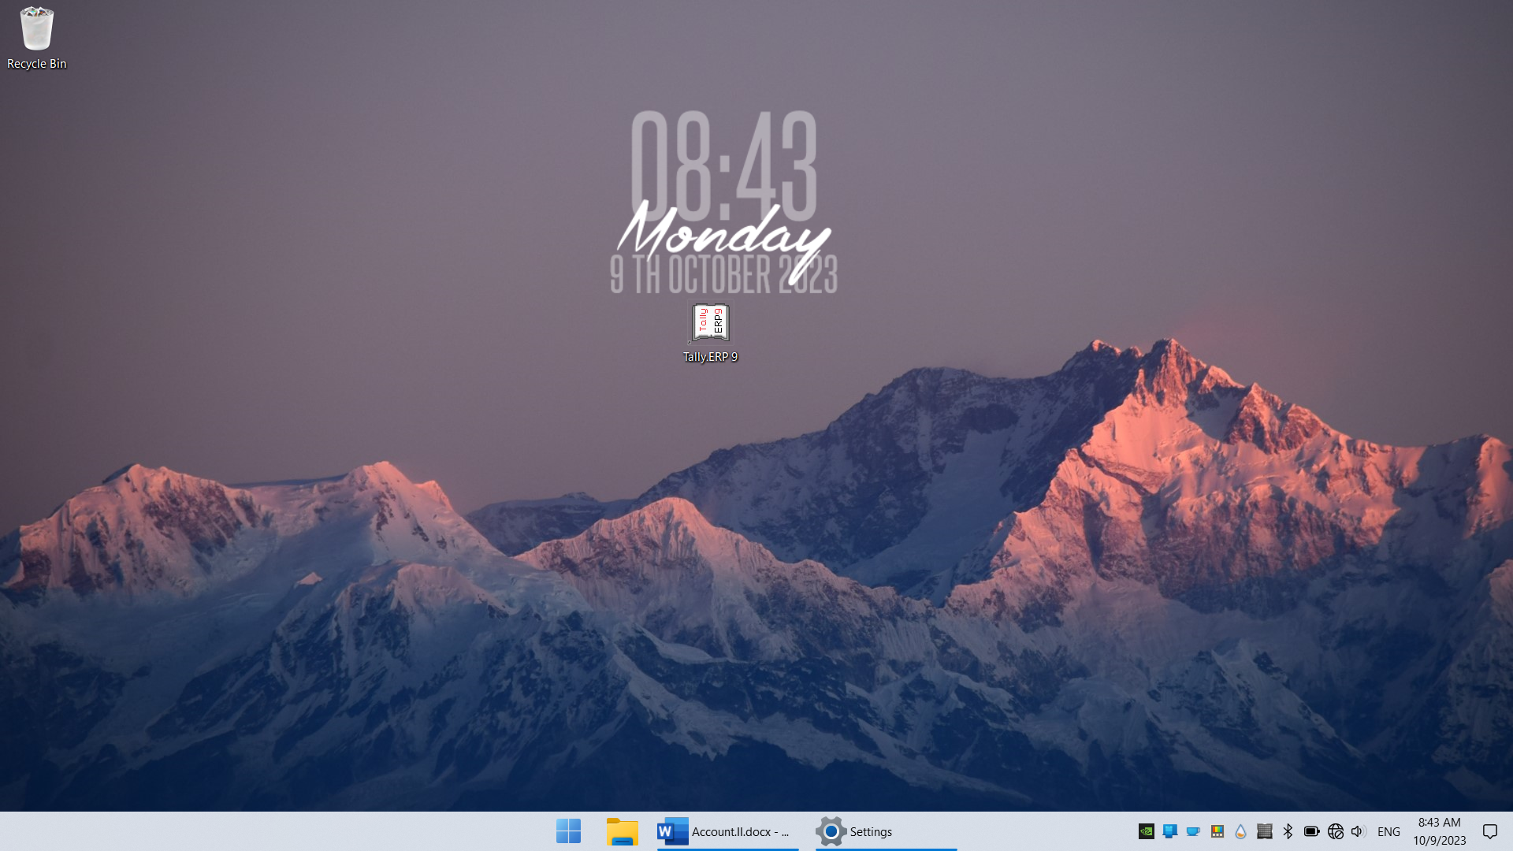

* Double Click on Tally. ERP 9 Icon or select and press Enter on Tally. ERP 9 Icon to start the Tally. ERP program

# **Select Company: Main Screen**

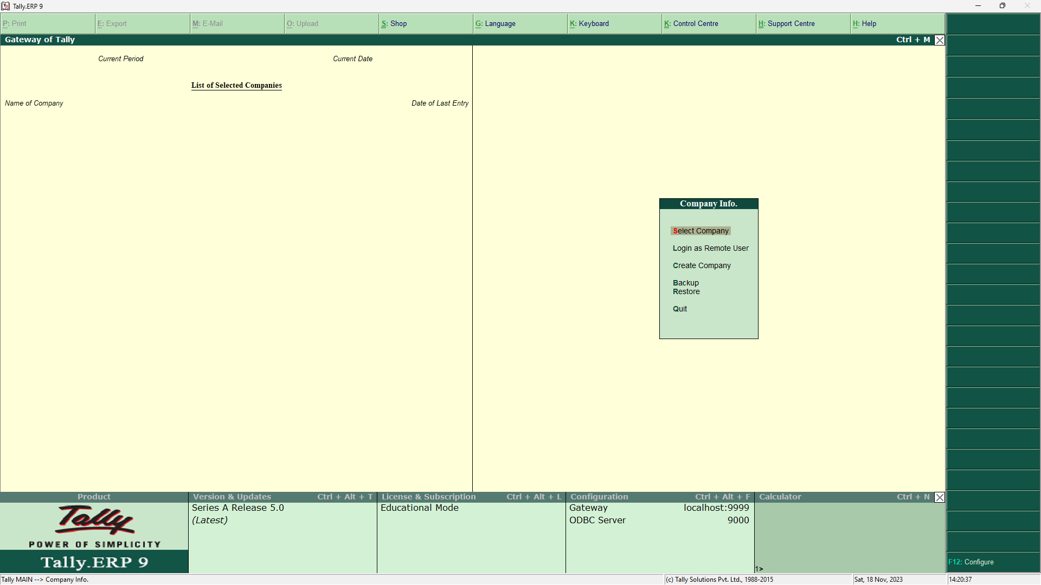

* Enter on Select or Press ‘F1’ to open the desired Company

# **Choose Company**

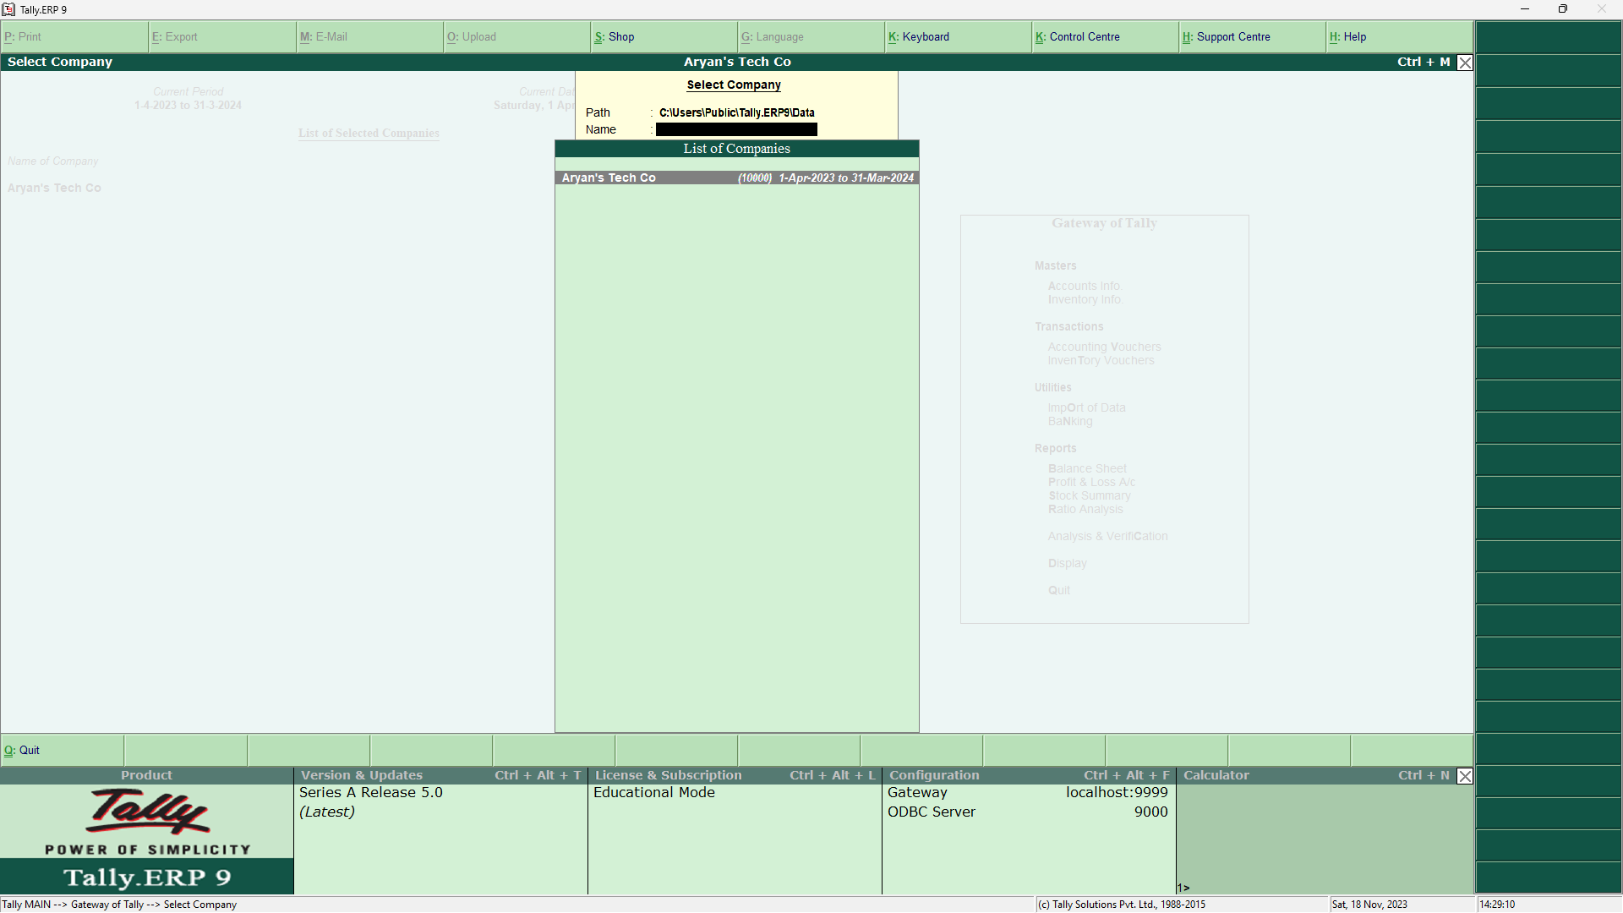

* Choose the Relevant Company from the list and press Enter

# **Gateway of Tally**

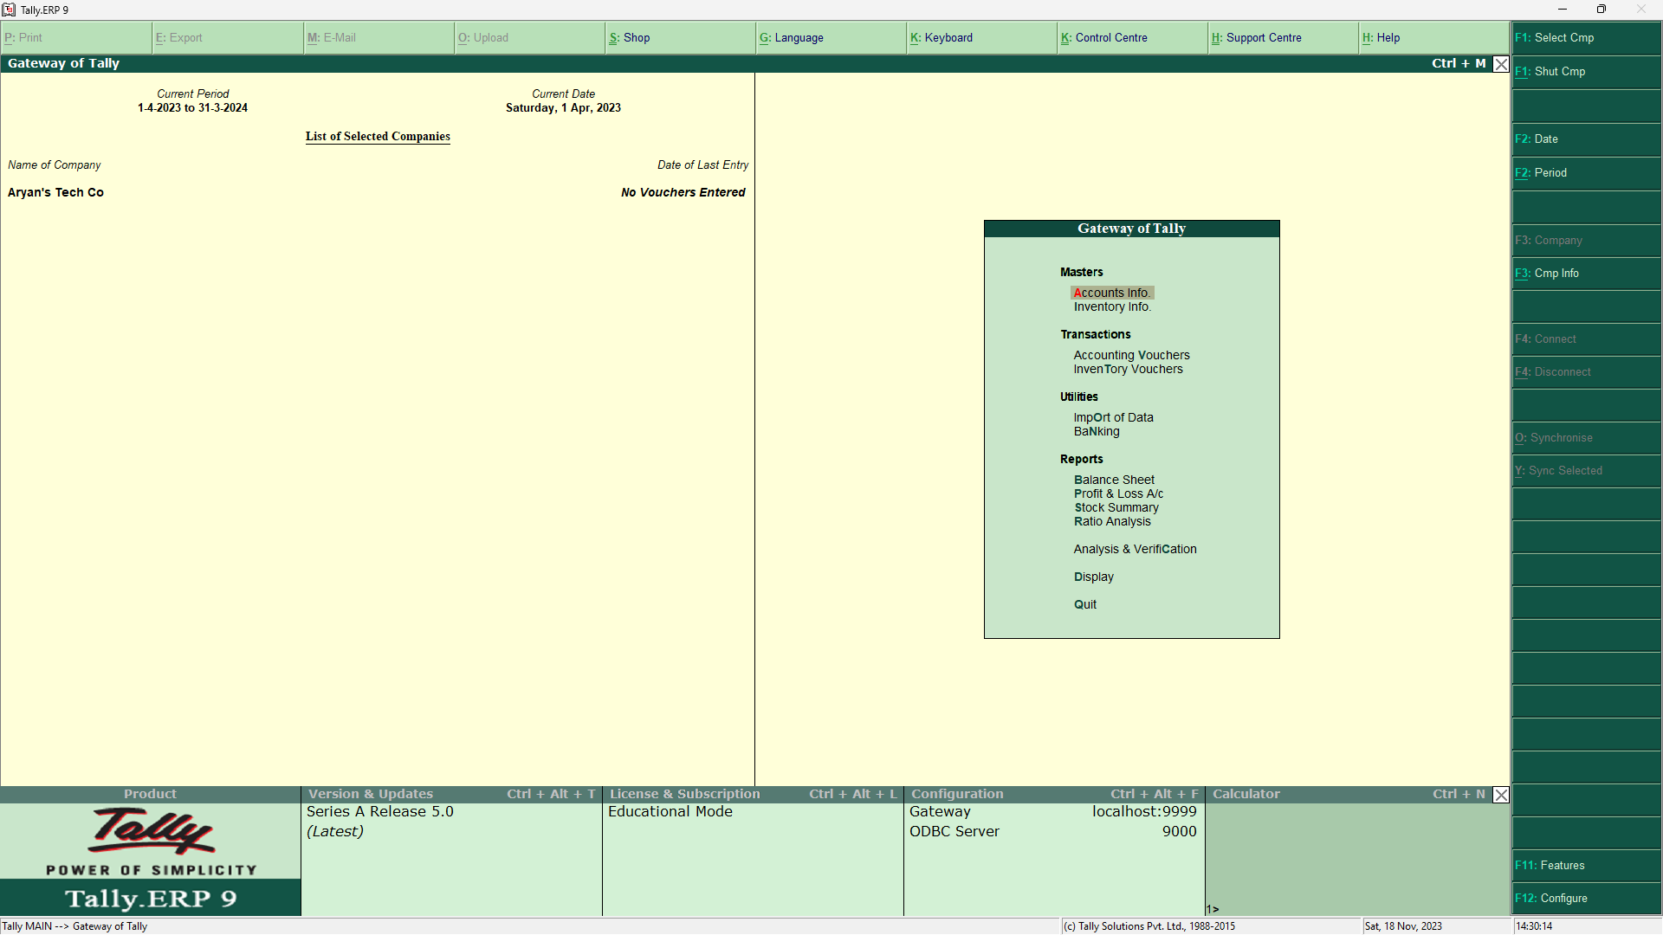

* At this screen, it can be seen as to which company is open, period of operation current date and the date of last entry

# **Change Accounting Period**

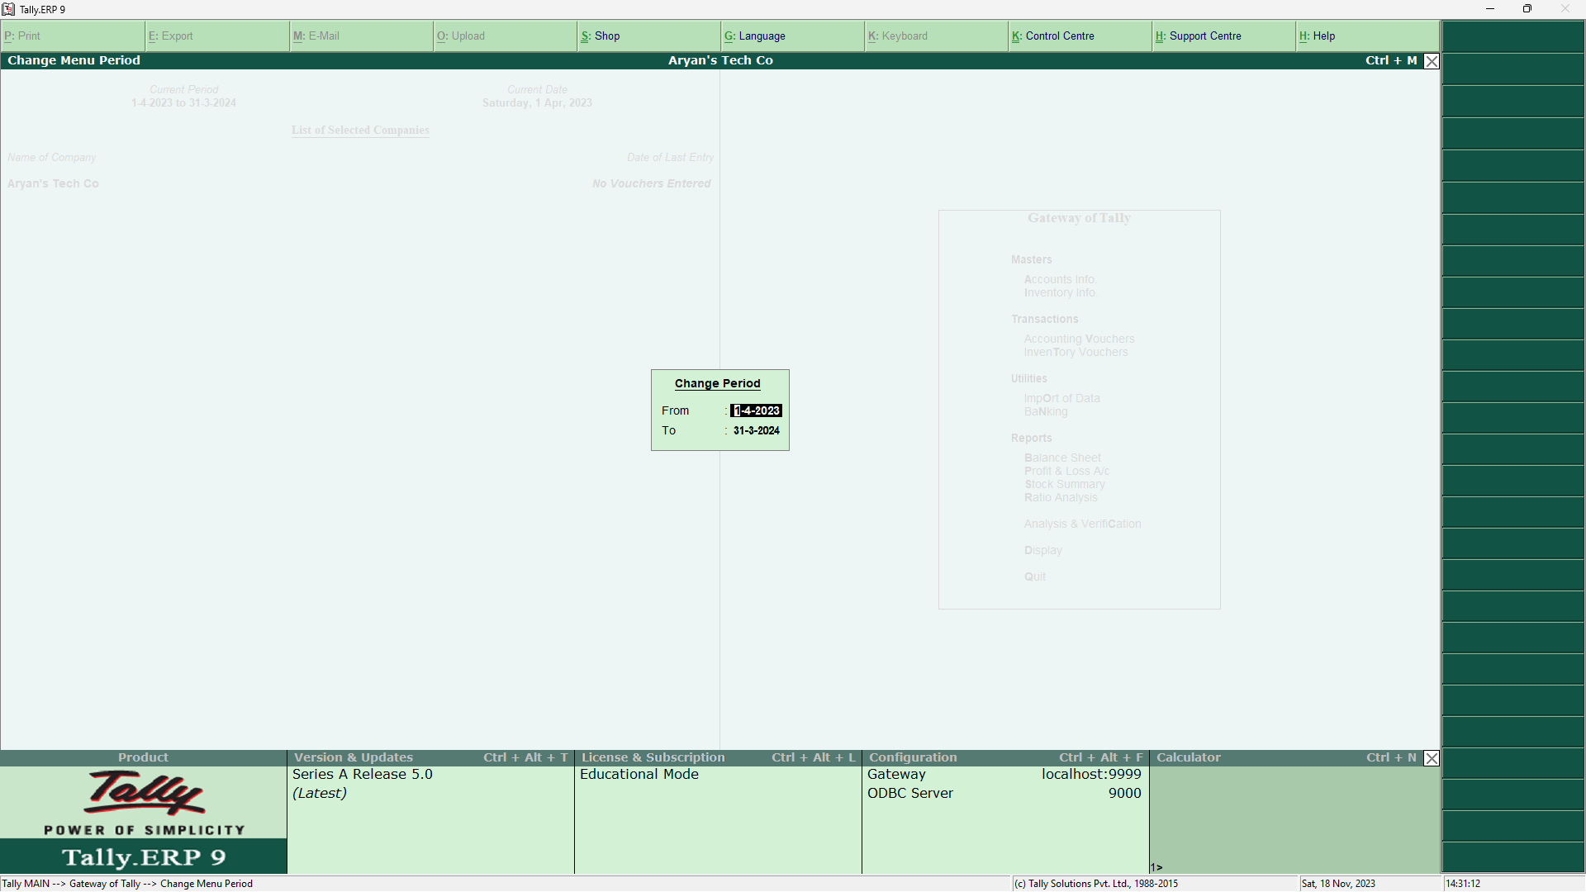

* Press “ALT + F2” to change the period for which accounting is to be done.

# **Alter Company/Create New Company**

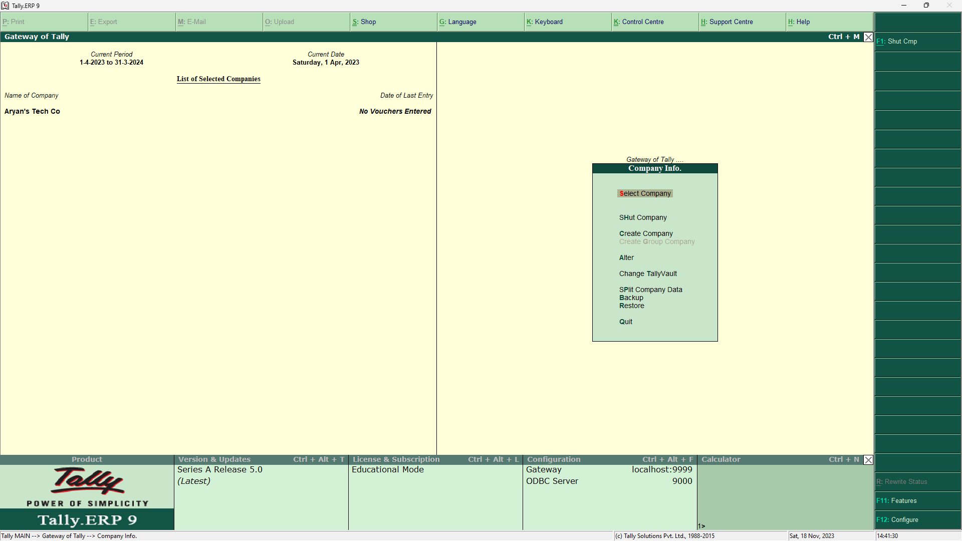

* After pressing “ALT + F3”, the company info screen is displayed, in which options for Altering company master data, backup etc are seen (Alter)

# **For Making Accounting Entries: Select Accounting Vouchers**

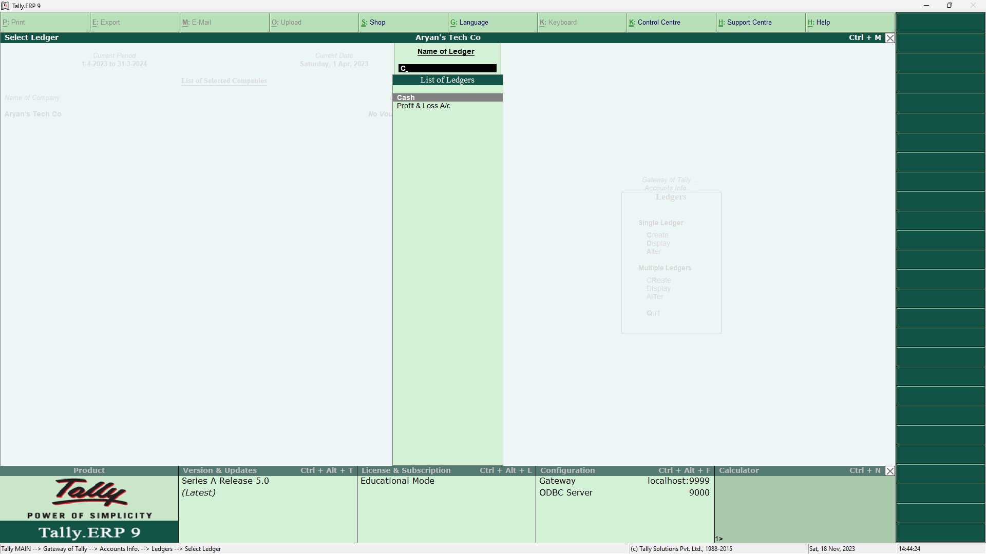

Press the respective key as per required:

* F4: Contra
* F5: Payment
* F6: Receipt
* F7: Journal
* F8: Sales
* F9: Purchase

CONTRA ENTRY

Amount withdrawn from the Bank

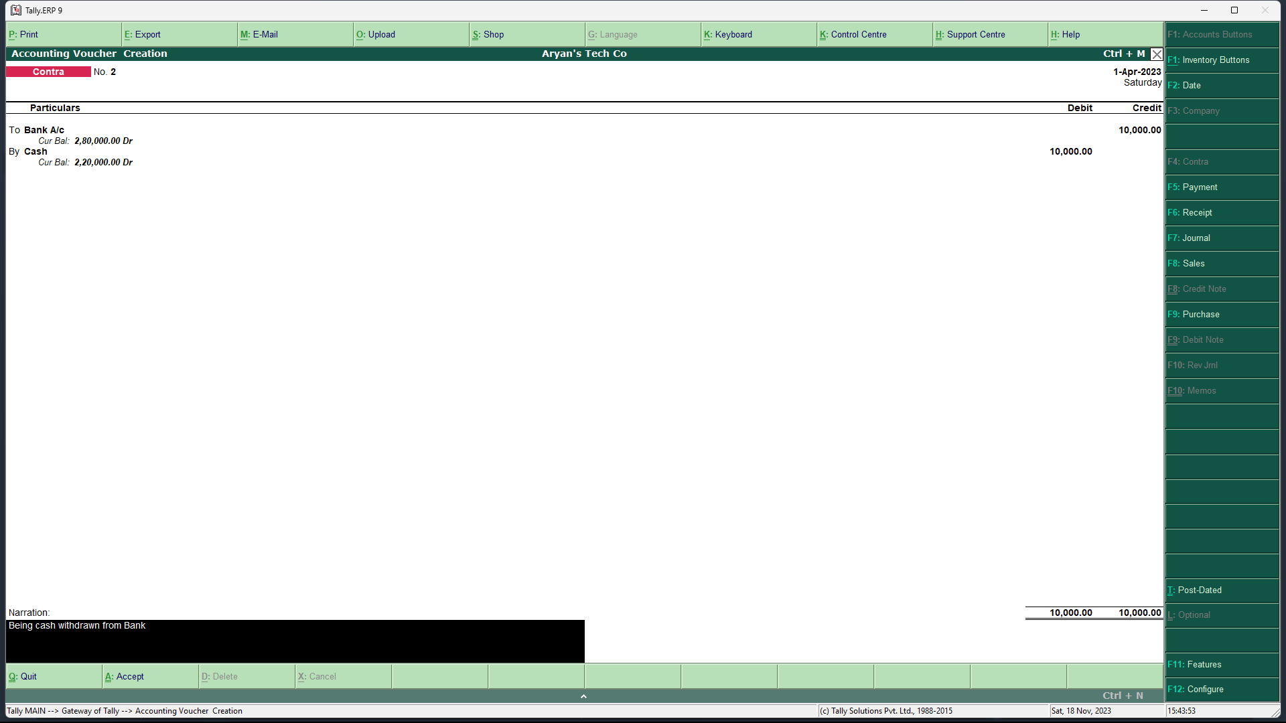

Amount deposited into the Bank

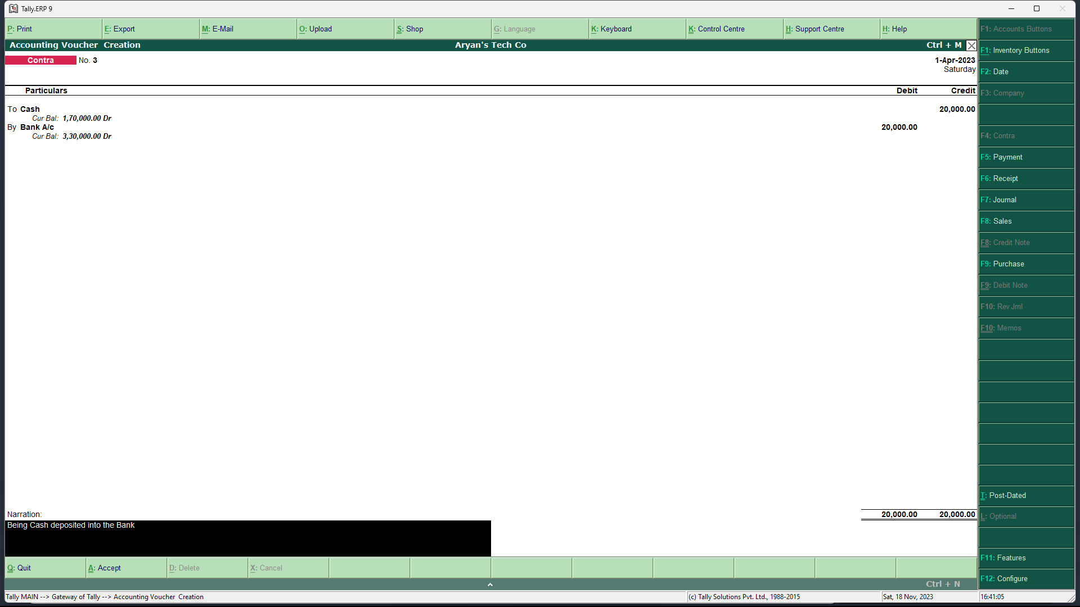

PAYMENT ENTRY

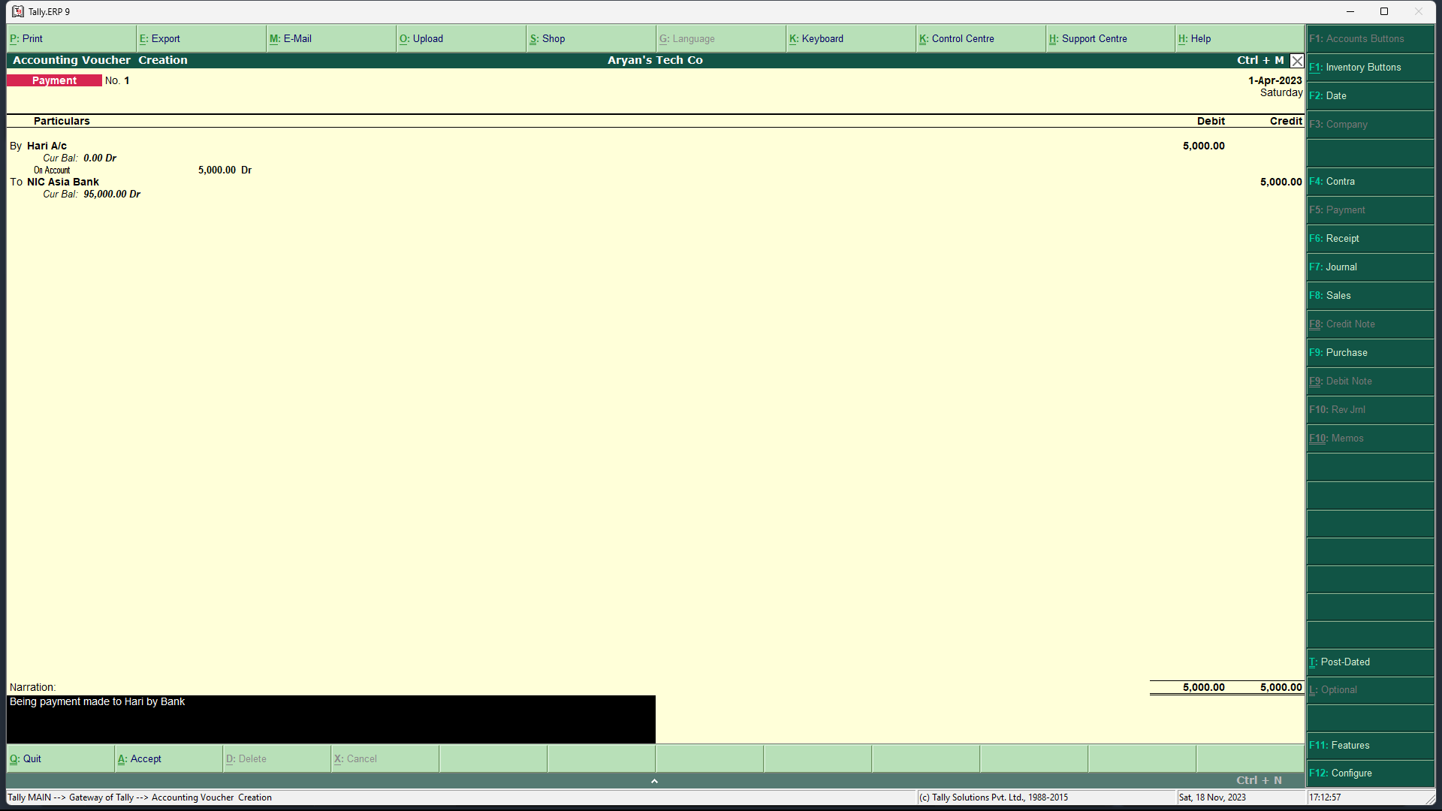

RECIEPT ENTRY

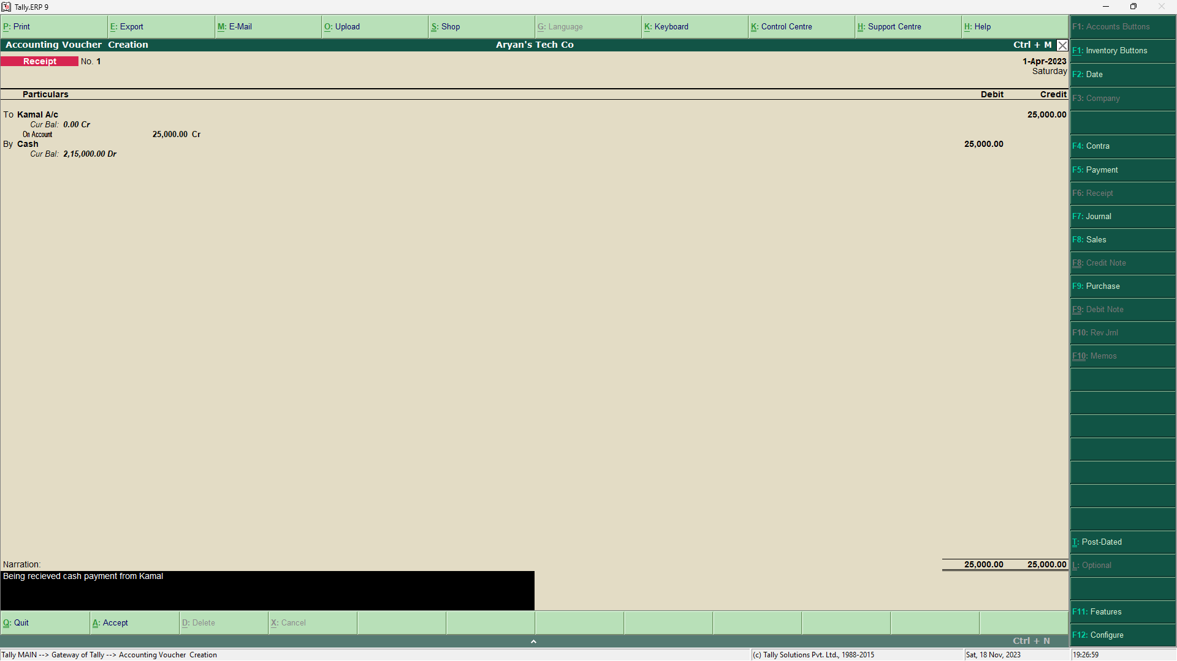

# **Monthly Report of specific Ledgers**

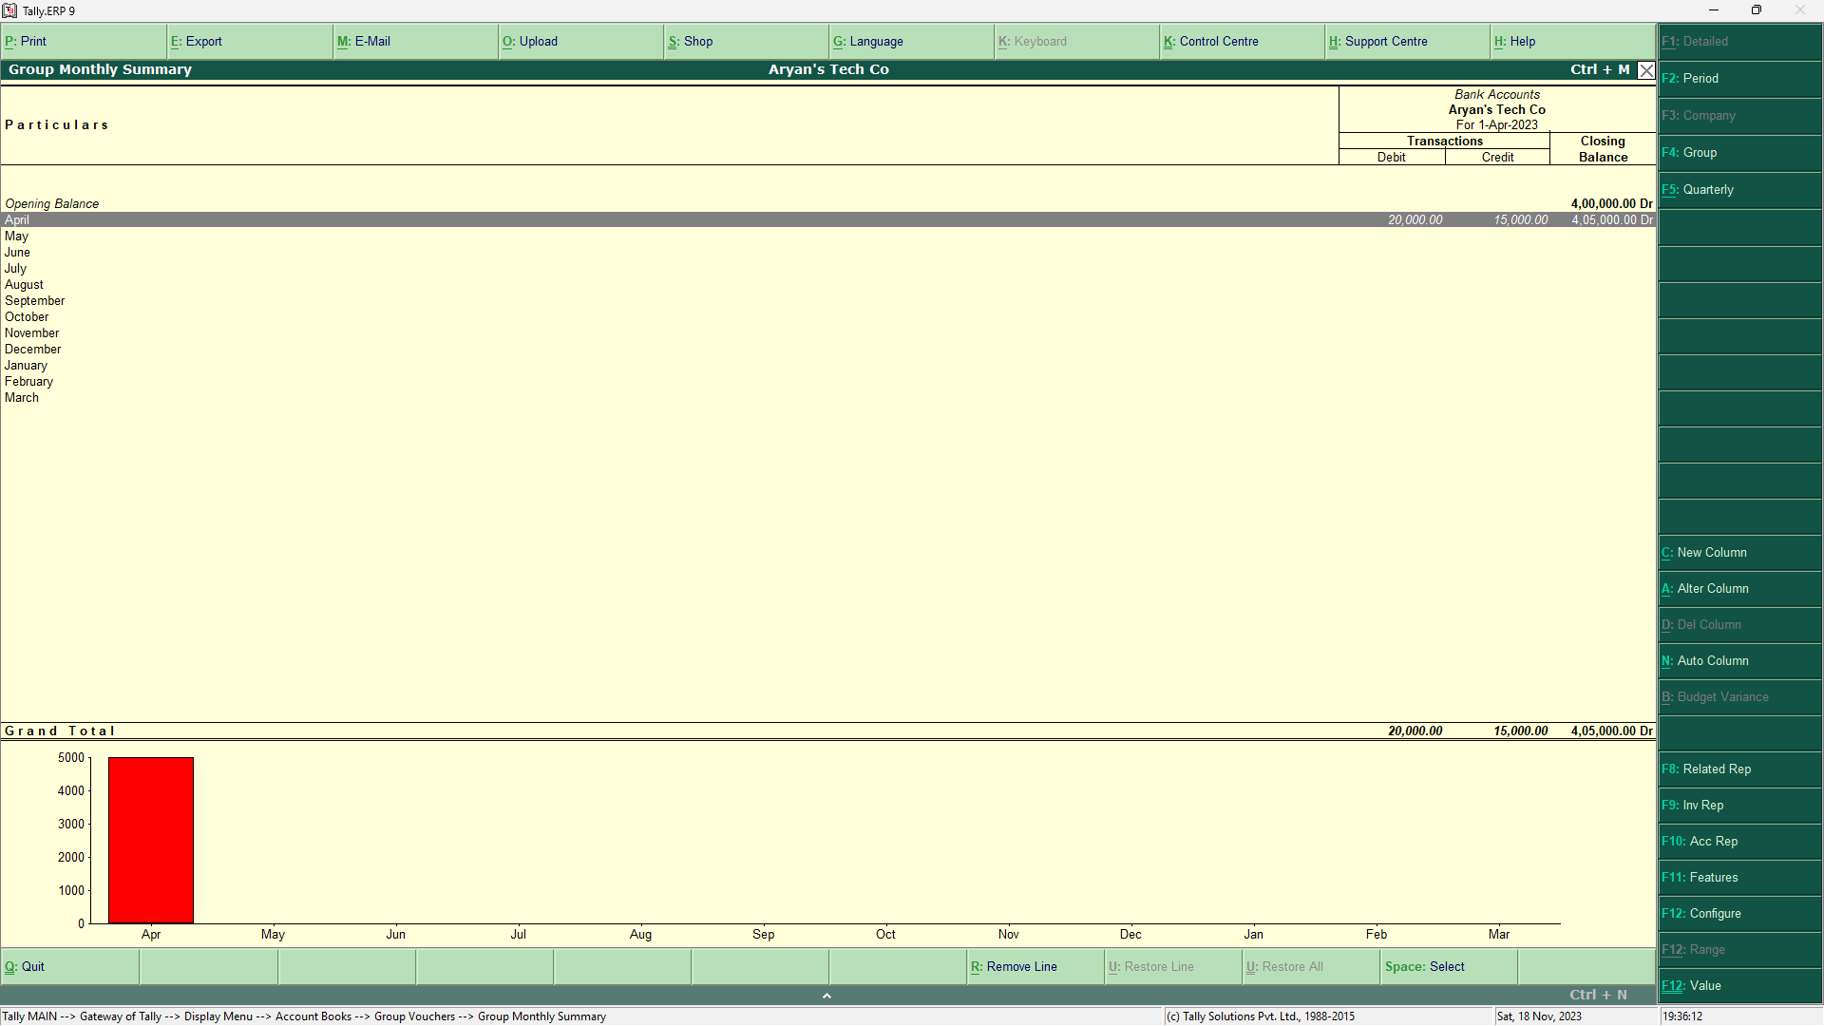

* We can easily access the monthly inflow and outflow of a particular ledger and its Monthly closing balance.
* We can achieve so by following this path: Tally MAIN > Gateway of Tally > Display Menu > Account Books
* Then we can select the desired ledger and press F6 to get its monthly report.

# **Daily Report of specific Ledgers**

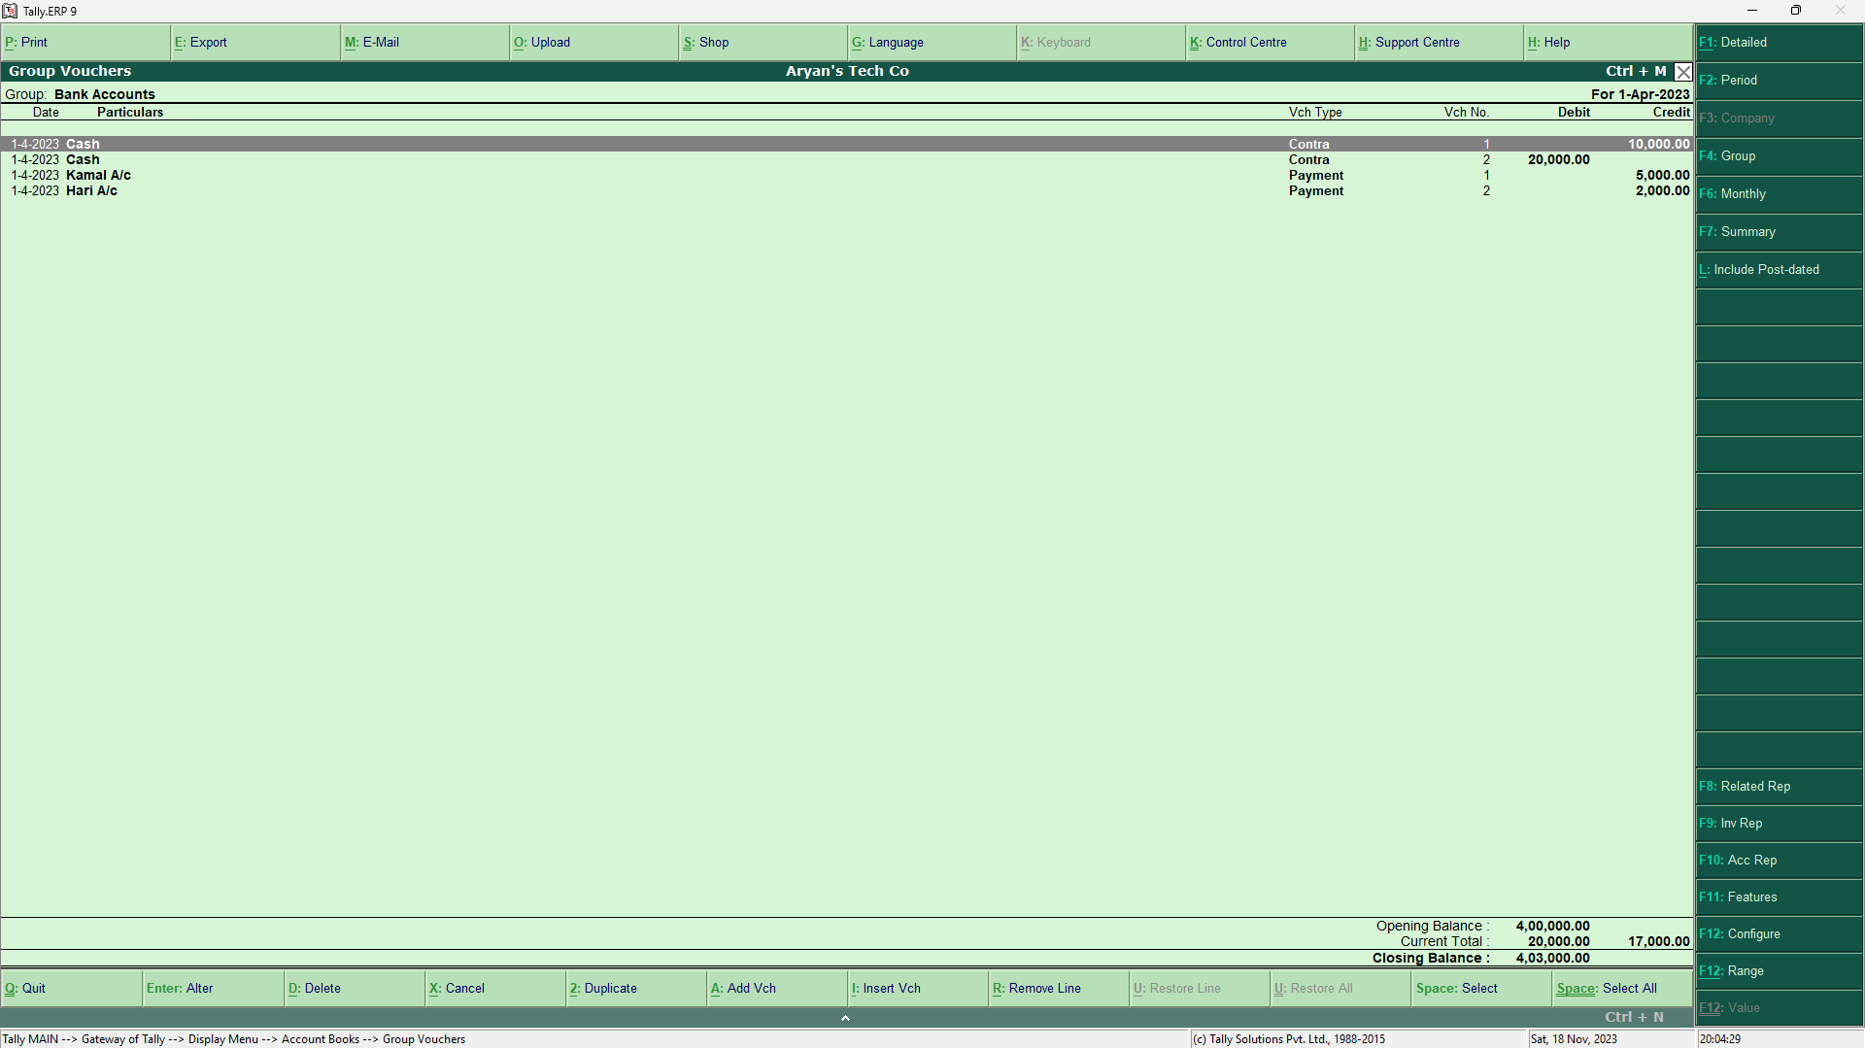

* Just like Monthly Report, we can easily access the daily inflow and outflow of a particular ledger.
* We can achieve so by following this path: Tally MAIN > Gateway of Tally > Display Menu > Account Books
* Then we can select the desired ledger and see its day wise transactions.

# **Preparing Bank Reconciliation Statements**

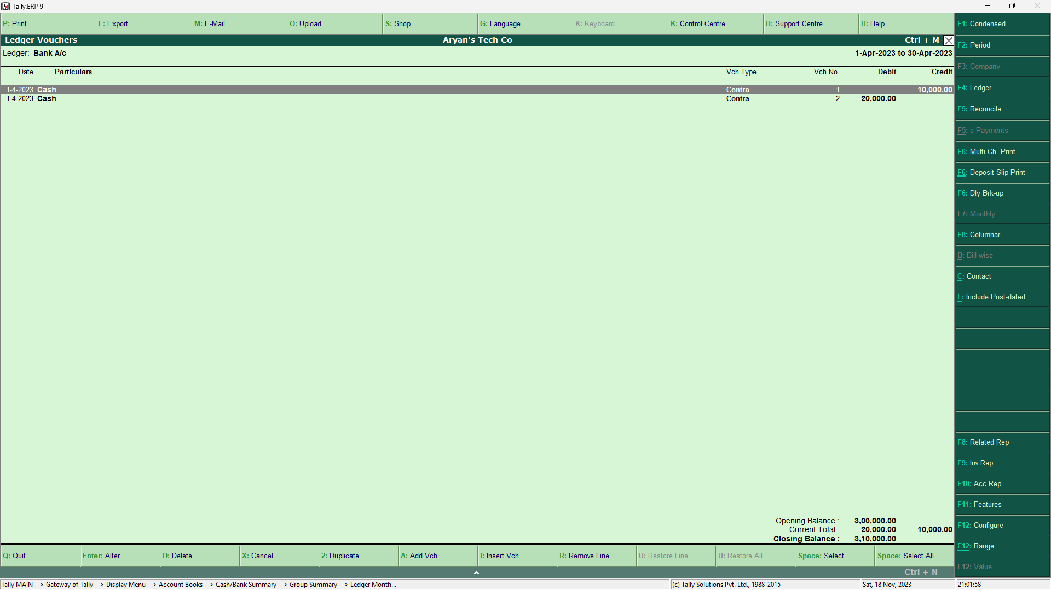

* One can easily access the Bank Reconciliation Statement by visiting: Gateway of Tally > Display > Account Books > Cash/Bank Book
* After that, select the required bank account and press Enter on the required month.
* Then, Press F5 – the shortcut key for bank reconciliation in Tally. ERP 9.

# **Printing**

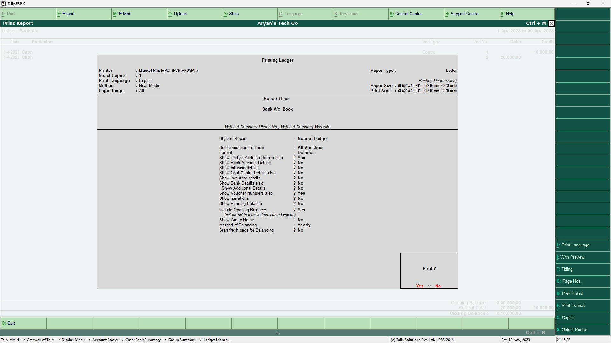

* To print any required page, Press “ALT + P” and select the required details.
* For Print Preview: ALT + I
* For Title Editing: ALT + T
* For No. Of Copies: ALT + C

# **Trial Balance in Tally**

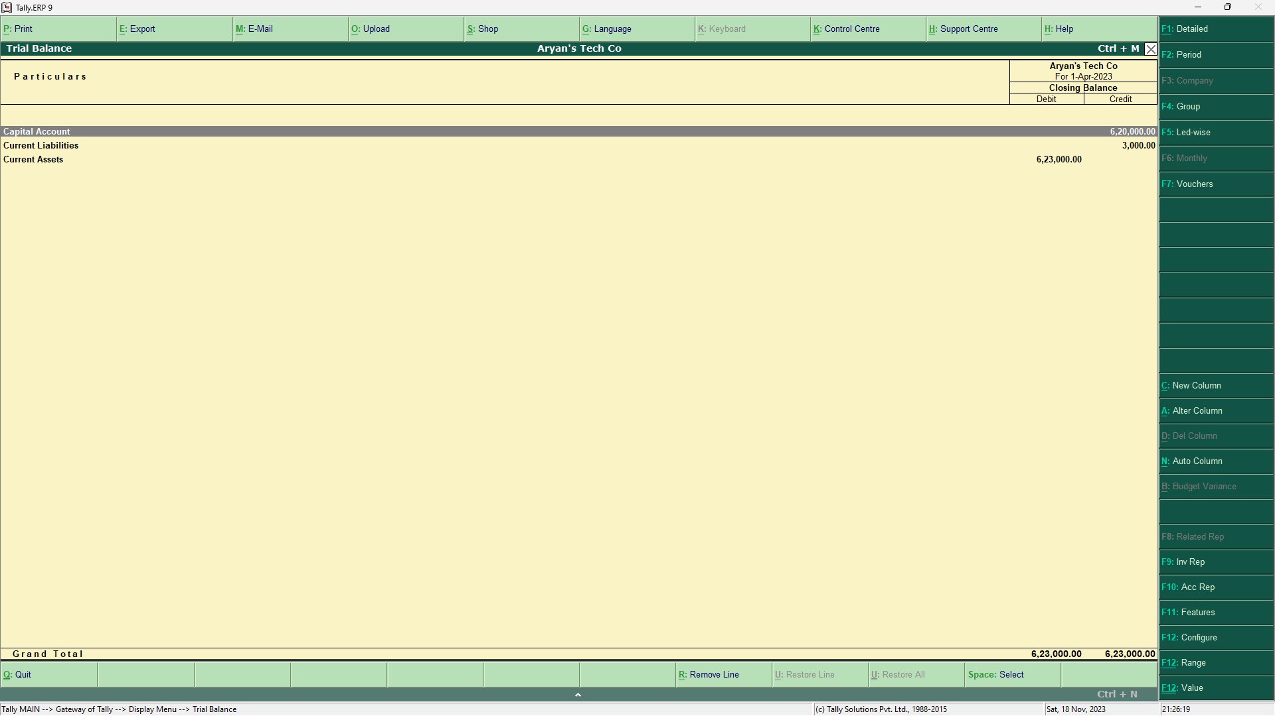

* Trial Balance can be accessed through the following path: Gateway of Tally > Display > Trial Balance

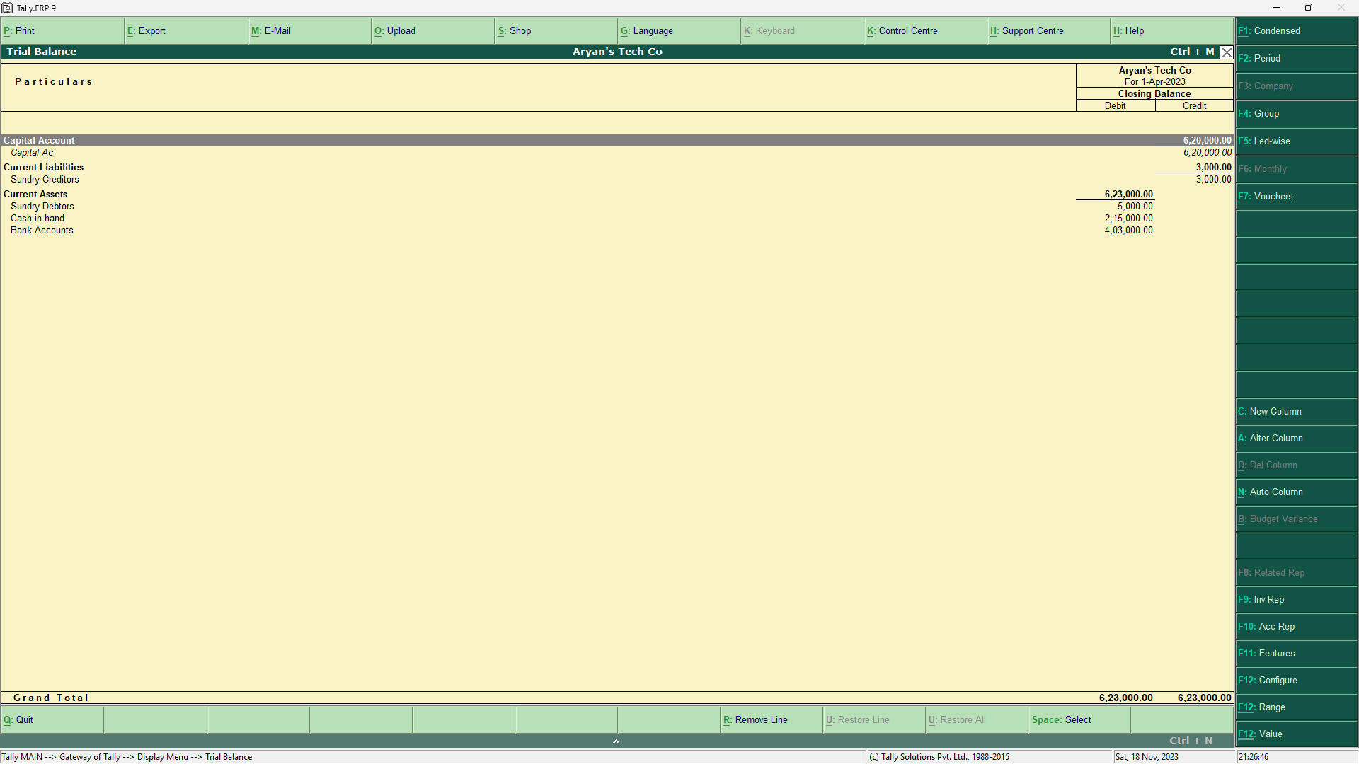

* We can get the detailed Trial Balance by pressing “ALT + F1”

# **Profit and Loss A/C in Tally**

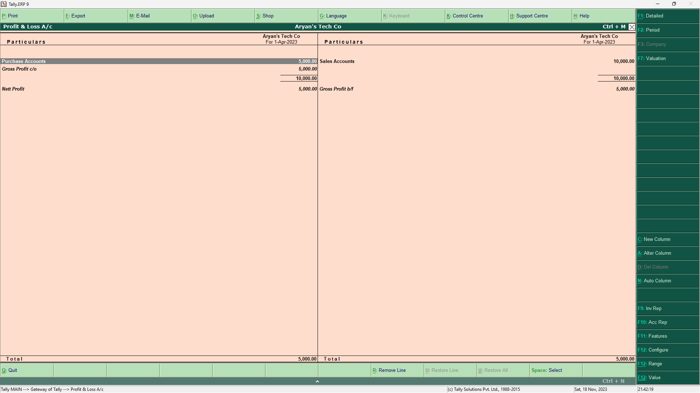

* Profit and Loss A/C can be accessed through the following path: Gateway of Tally > Profit & Loss A/c

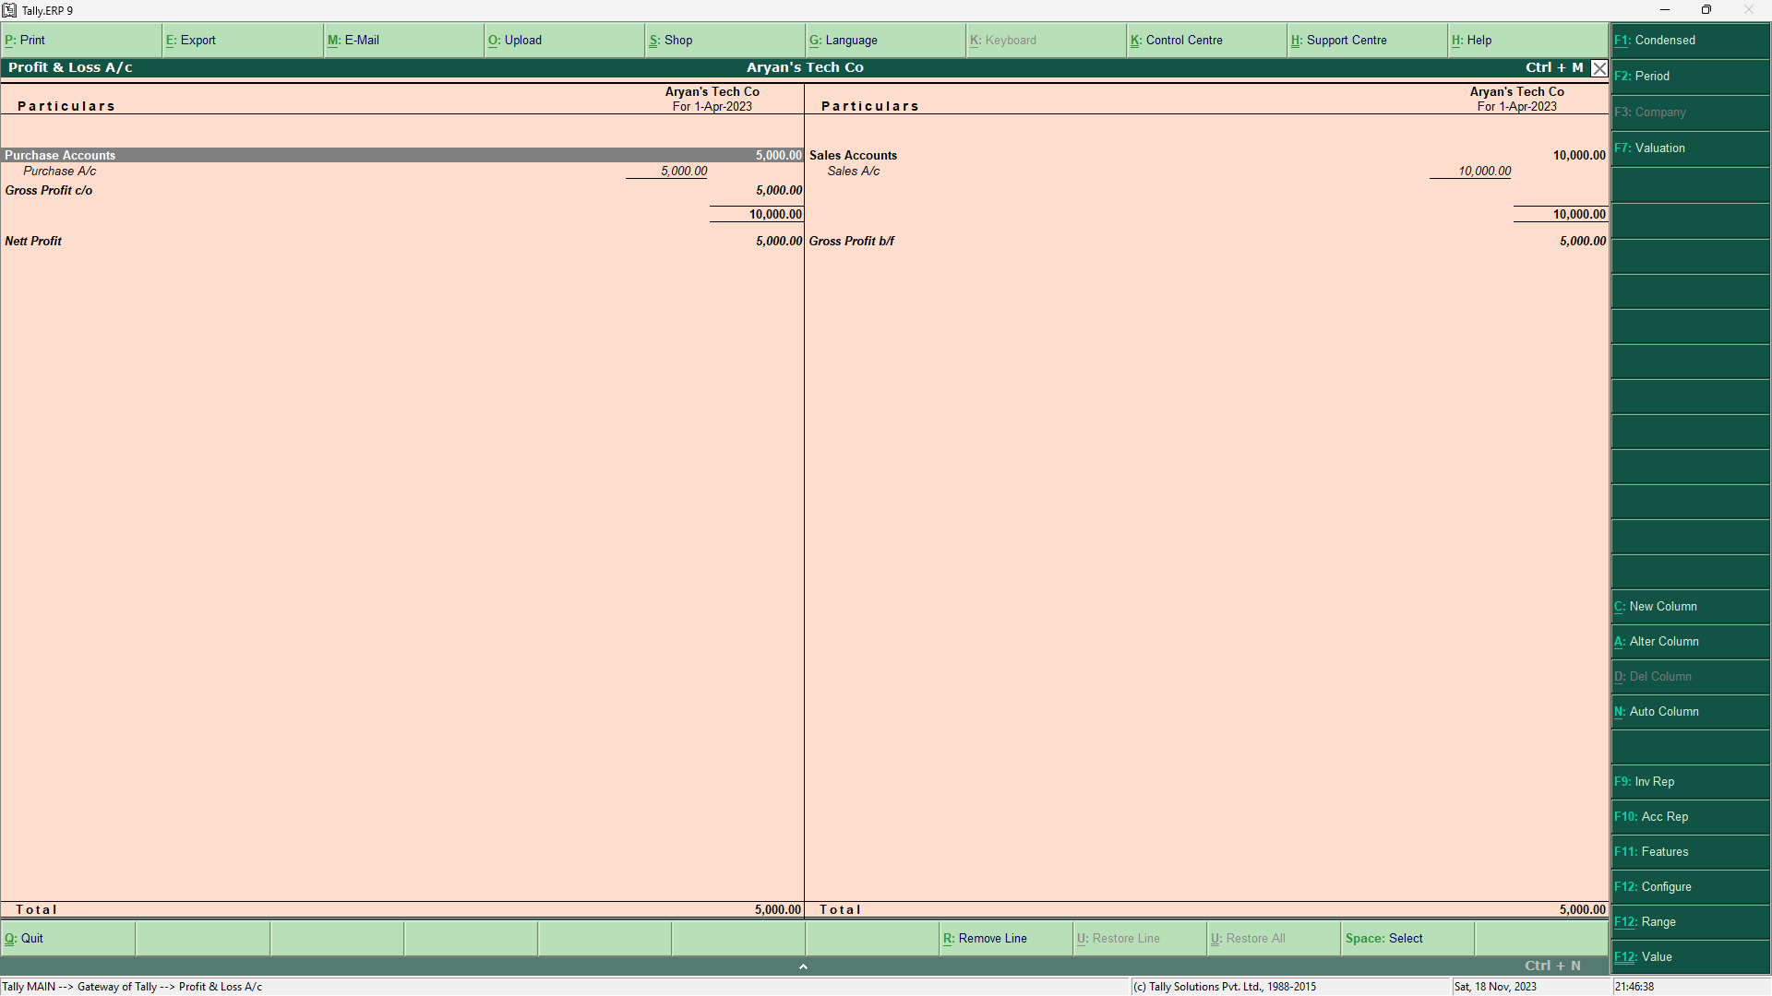

* We can get the detailed Profit and Loss A/C by pressing “ALT + F1”

# **Balance Sheet in Tally**

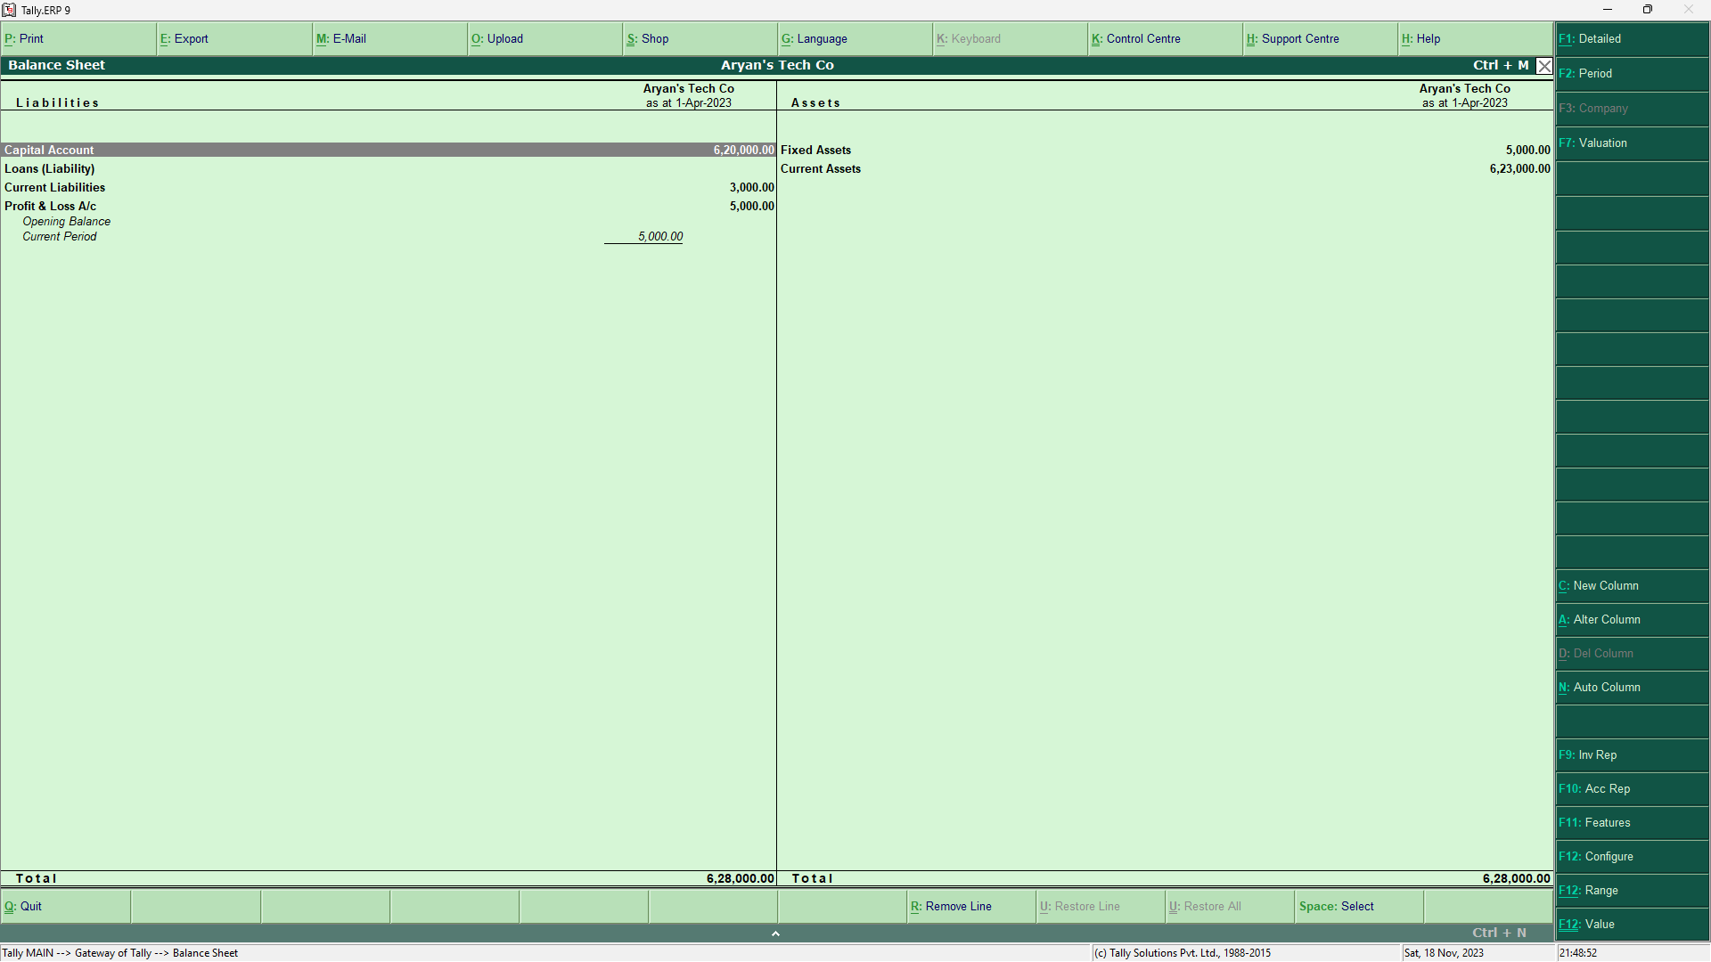

* Balance Sheet can be accessed through the following path: Gateway of Tally > Balance Sheet

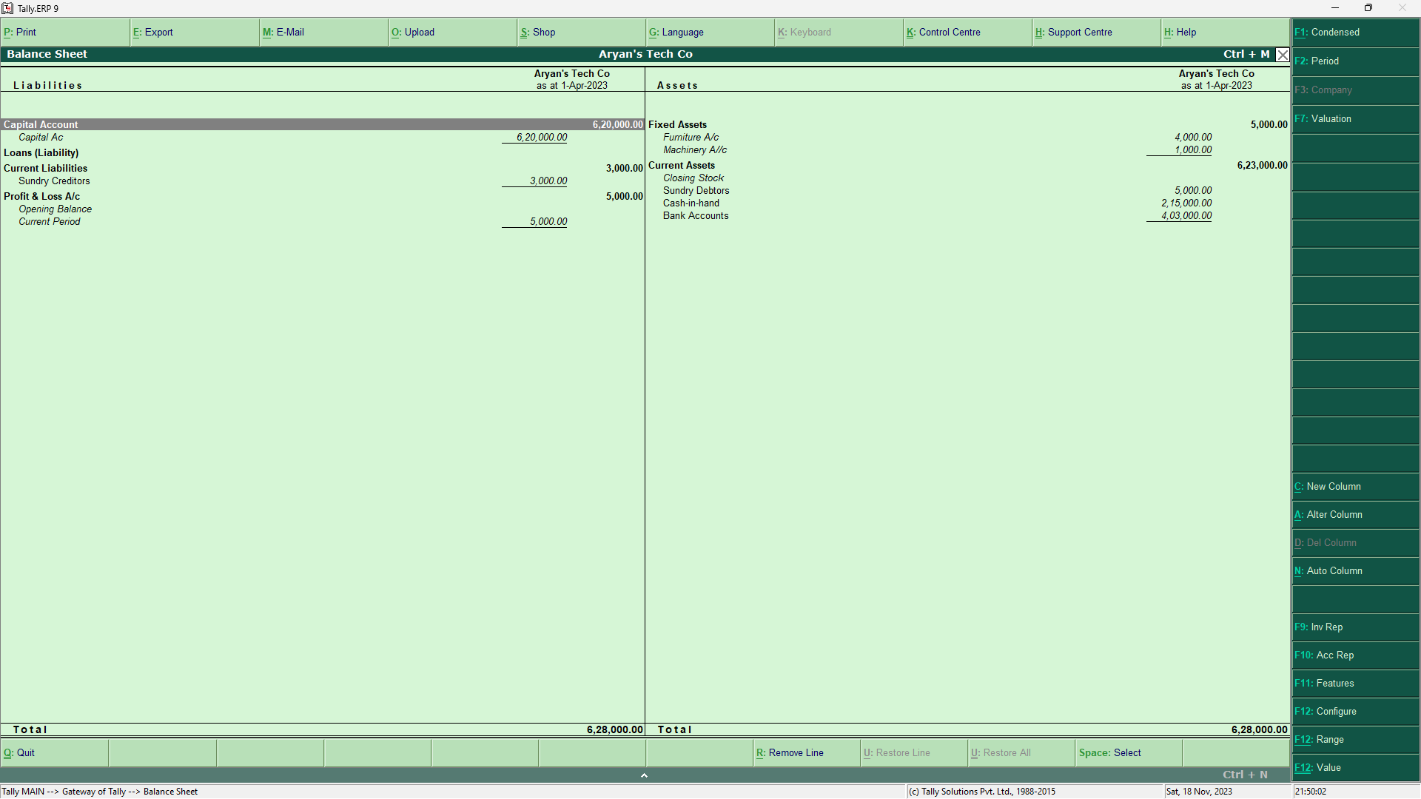

* We can get the detailed Balance Sheet by pressing “ALT + F1”